# Year End Processing Resources

1. What resources are available to year end processing questions?

# Month End & Quarter End Processing

1. Do we still have to do our regular month end and quarter end processing in Ascente and Traverse?

# General Ledger

1. What do I need to do to start processing in fiscal year new payroll year in Traverse?
2. What do we need to do in Traverse to close a fiscal year?
3. When I go to enter Work Order in Ascente, we get a message saying that the fiscal periods are not setup?

# Payroll

1. What is the difference between the Payroll Year and Fiscal Year?
2. Were our new payroll year payroll tax updates installed?
3. When can we start processing payroll in the new payroll year?
4. Do we need to have the new Traverse payroll year and formula tables for that new year need to be added if we do not do payroll check processing in Traverse?
5. Does the File / Change Payroll Year set it for every user?
6. How do I set my payroll year in Traverse?
7. We forgot to change to payroll year new payroll year and entered and posted all our timecards to payroll year current/old payroll year. What do we do?
8. How do I know what payroll year I am in when doing Timecard Entry?
9. If my pay period spans years, such as 12/28 from the current/old payroll year through 1/3 of the new payroll year, what payroll year do I need to be in?
10. Do I have to do my W-2’s and all payroll yearend processing for current/old payroll year before doing payroll processing in new payroll year?
11. When entering timecards, how can I tell what Payroll Year I am entering time in?
12. Do I need to file electronically?
13. W-2 & 1099 Forms, will they print on any vendors forms?
14. Before printing on the forms, we always you first print on plain paper and overlay the forms to be sure they will align correctly. This will prevent wasting forms during the alignment process.
15. The forms do not align with the data, what do I do?

# Accounts Receivable

1. What is required in Traverse – Accounts Receivable at year end?

# Accounts Payable

1. What is required in Traverse – Accounts Payable at year end?

# Ascente – Service Dispatch

1. What do we need to do in Ascente at year end for Service Dispatch?

# Ascente – Job Cost

1. What do we need to do in Ascente at year end for Job Cost?

# Ascente – Posting Dates

1. In Ascente, how do I know what fiscal year reports are being posted to?

# Ascente Mobile Pro

1. The payroll year needs to be advanced to new payroll year after all entries for current/old payroll year are completed and before any for new payroll year are entered.

# Document Retention

1. Can Ascente and Traverse print to PDF files?

# Year End Processing Resources

1. What resources are available to year end processing questions?
   1. You will find video’s and documents at these links:
      1. Compusource Web Pages:
         1. [compusource.com](http://www.compusource.com/)
         2. [servicecontractorsoftware.com](http://servicecontractorsoftware.com/)
      2. Year End Procedures: [Link](http://servicecontractorsoftware.com/client-support/year-end-procedures-ascente/)
      3. Training Videos: [Link](http://servicecontractorsoftware.com/client-support/training-videos/)

# Month End & Quarter End Processing

1. Do we still have to do our regular month end and quarter end processing in Ascente and Traverse?
   1. It is assumed that you are still completing your normal month end processing for all the Ascente & Traverse modules.
   2. It is assumed that you are also completing your normal quarter end processing for the modules that have quarterly processing requirements such as payroll or sales tax reporting.

# Payroll

1. What is the difference between the Payroll Year and Fiscal Year?
   1. Payroll Year refers to the year the transactions will be paid and reported on a W2.
   2. Fiscal Year refers to your General Ledger reporting year, which may be different than a calendar year.
2. Were our new payroll year payroll tax updates installed?
   1. Run the Traverse / Payroll / Setup & Maintenance / Formula Tables program and see if the payroll year new payroll year records are there. If they are, you have had the new payroll year payroll tax update installed.

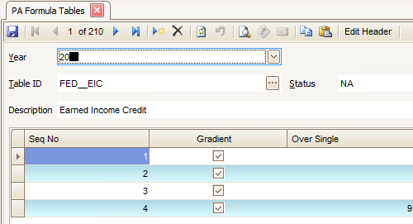

The new payroll year has been installed if you can view a record for the new payroll year.

* 1. If the new payroll year and formula tables do not exist, call Compusource to get them installed.

1. When can we start processing payroll in the new payroll year?
   1. After you have completed all payroll processing in current/old payroll year.
      1. Post all unposted timecard records for current/old payroll year.
      2. Run the Ascente File / Change Payroll Year. Set it to new payroll year.
   2. After Compusource has installed the year end updates and created the new payroll year.
   3. After you have completed the creation and setup of the new payroll year
      1. After you have set your companies SUI rate in the Traverse / Payroll / Setup & Maintenance / Formula Tables. Find your payroll state P??_SUI and enter your companies assigned rate. This will not default from the current/old payroll year rate.

This needs to be the new payroll year. In this case it should be new payroll year.

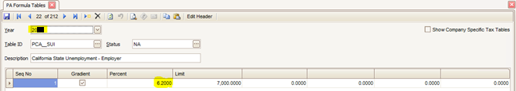

This needs to be set to your company’s assigned SUI rate. *State Unemployment Insurance*

1. Do we need to have the new Traverse payroll year and formula tables for that new year need to be added if we do not do payroll check processing in Traverse?
   1. If you do timecard entry, you need the new Traverse payroll year created.
   2. You must have the Traverse - Payroll formula tables installed. You will not be able to add new Traverse – Payroll – Employee records for the new year if the if the payroll formula tables for the new year have not been installed.
2. Does the File / Change Payroll Year set it for every user?
   1. No, *every user* must change their payroll year themselves. This is only required if the user enters timecards.
3. How do I set my payroll year in Traverse?
   1. Traverse / Payroll / Periodic Processing / Change Payroll Year
   2. This needs to be done by every individual operator processing payroll in Traverse so that all payroll reports and processing is being done in the correct payroll year.
4. We forgot to change to payroll year new payroll year and entered and posted all our timecards to payroll year current/old payroll year. What do we do?
   1. This is a two-step process:
      1. While in current/old payroll year, enter all of the same timecard entries that you posted, but make the hours be negative to back out the original entries that were posted in error. Register and update that time using the same GL Posting Date that was previously used.
      2. Now change to payroll year new payroll year. Enter all the timecard records again as originally entered. Register and update the timecard records. That should be all you need to do.
5. How do I know what payroll year I am in when doing Timecard Entry?
   1. When you select an employee, the current payroll year will be displayed under the employee code. Note that below indicates that the current payroll year is current/old payroll year.

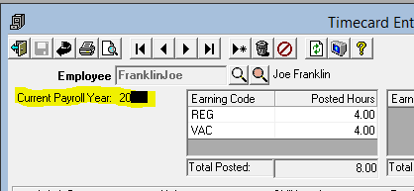

1. If my pay period spans years, such as 12/28 from the current/old payroll year through 1/3 of the new payroll year, what payroll year do I need to be in?
   1. If the payroll check is dated in new payroll year, you need to be in payroll year new payroll year when you enter the timecard records.

1. Do I have to do my W-2’s and all payroll yearend processing for current/old payroll year before doing payroll processing in new payroll year?
   1. No, you can do W-2’s and all other reporting in new payroll year. Just make sure that you set your payroll year to new payroll year before entering the timecard records.
2. When entering timecards, how can I tell what Payroll Year I am entering time in?
   1. After you select an employee, the payroll year will display below the employee code. This is important that in January, time is entered in the correct payroll year.

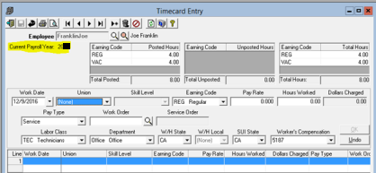

1. Do I need to file electronically?
   1. The United States Social Security Administration (SSA) requires that all employers with 250 or more employees file W-2 forms electronically. TRAVERSE creates the text-based W2Report file you send to the SSA in the EFW2 magnetic media format specified by the SSA. The SSA requirements for this file are described on the www.ssa.gov website. Check with your states tax authority before filing W-2s.
2. W-2 & 1099 Forms, will they print on any vendors forms?
   1. They are designed for a specific form that is pretty standard, but we can’t say they will print on *any* form. Open Systems recommends this vendor <http://www.nelcosolutions.com/> . Be sure to look For Traverse 11 or 10.5 forms. Whichever is appropriate.
   2. PR - W-2 Form
      1. They can order ‘2 - Per Page’ or ‘4 - Per Page’ forms.
      2. The Traverse EPTR (Enhanced Payroll Tax Reporting) module will print the completed forms on plain paper.
   3. AP – 1099 MISC Form
3. Before printing on the forms, we always you first print on plain paper and overlay the forms to be sure they will align correctly. This will prevent wasting forms during the alignment process.

1. The forms do not align with the data, what do I do?
   1. Assuming that forms being used are compatible and the data just needs to be adjusted slightly horizontally or vertically a little bit, they can preview the forms and then click on the Page Setup button  to adjust the margins.
   2. 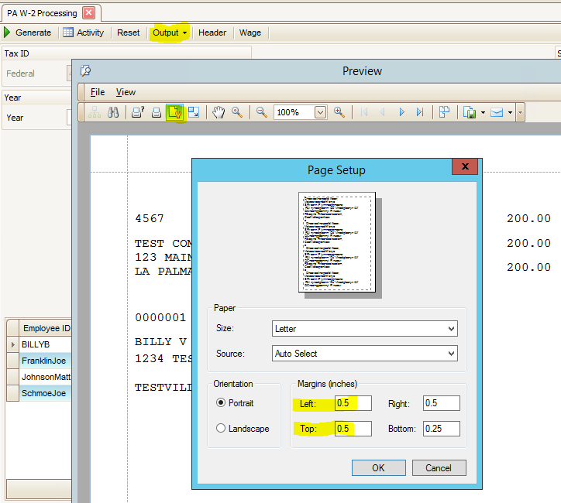

# Accounts Receivable

1. What is required in Traverse – Accounts Receivable at year end?
   1. Nothing is required by Traverse, but we recommend that you do the following:
      1. Complete all AR sales and payment processing for the year.
      2. Complete your normal month end processing.
      3. Balance your AR sub ledger to your GL receivable accounts. Traverse / General Ledger / Interactive Views / Subsidiary Ledger Audit View.
      4. Print a final Detailed AR Aged Trial Balance Report
      5. Print or file any of the Management Reports that you may need to the previous year.
   2. See more detail processing notes using this [link](http://servicecontractorsoftware.com/client-support/year-end-procedures-ascente/).

# Accounts Payable

1. What is required in Traverse – Accounts Payable at year end?
   1. Complete all AP invoicing and payment processing for the month and year.
   2. Complete all of your normal month end processing.
   3. Process your 1099’s for all of your 1099 vendors
   4. Verify that all of the vendors for 1099’s are setup to print a 1099
   5. Verify their totals for the year using the Traverse / Accounts Payable / Periodic Processing / AP 1099 Processing program to edit the vendor totals as necessary.
   6. We recommend that you do the following:
      1. Balance your AP sub ledger to your GL receivable accounts. Traverse / General Ledger / Interactive Views / Subsidiary Ledger Audit View.
      2. Print a final Detailed AP Aged Trial Balance Report
      3. Print or file any of the Management Reports that you may need to the previous year.
   7. See more detail processing notes using this [link](http://servicecontractorsoftware.com/client-support/year-end-procedures-ascente/).

# General Ledger

1. What do I need to do to start processing in fiscal year new payroll year in Traverse?
   1. You need to run the Traverse / System Manager / Company Setup / [Period Conversion](http://www.compusource.com/FTP/Training_Videos/ASCENTE/2017/TraverseSMPeriodConversion_20171001.wmv) and add the record for new payroll year has not been setup. If it is not on the dropdown list, just type it in and it will prompt you to add it. This should be done by someone in the accounting department if you are not sure.

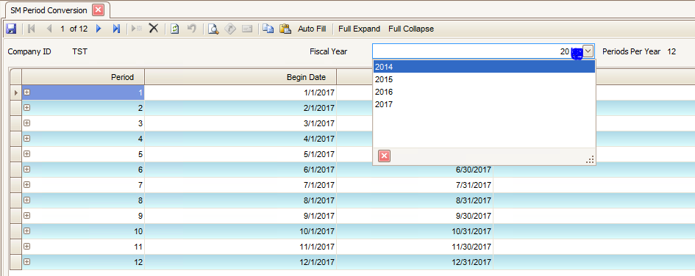

Figure : Traverse / System Manager / Company / SM Period Conversion

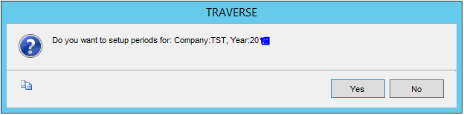

* 1. If a new year is being created, you will be prompted with ‘*Do you want to setup periods for Company XXX, Year ####*’. Click on the [Yes] button.

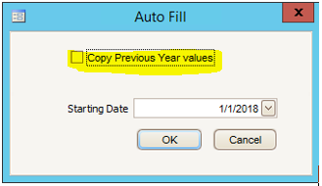

* 1. Verify that the created fiscal period *start* and *end* dates are correct, correct if necessary. Typically, you will just click the ‘Copy Previous Years values’ and click the [OK] button.

1. What do we need to do in Traverse to close a fiscal year?
   1. Traverse / System Manager / Company Setup / [Period Conversion](http://www.compusource.com/FTP/Training_Videos/ASCENTE/2017/TraverseSMPeriodConversion_20171001.wmv) needs to be run to create the new fiscal year.
   2. Run the Traverse / General Ledger / Periodic Processing / [Update Current Year](http://www.compusource.com/FTP/Training_Videos/ASCENTE/2017/TraverseGLUpdateCurrentYear_20171001.wmv) program to roll the balance sheet totals into the new year and calculate and roll forward the retained earnings.
      1. Before doing this, you should:
         1. Review the detail process at <http://www.compusource.com/Support/year-end-procedures/year-end-procedures-Ascente.php>
         2. Print the Chart of Accounts list on the Master Lists menu. Check the box to print the clear and consolidate information. Once the list is printed verify the following information:
            1. The income statement accounts have an account type between 500 and 890.
            2. The balance sheet accounts have an account type between 005 and 465.
            3. The step and clear to account information.
         3. Use the Chart of Accounts function on the Setup and Maintenance menu to edit incorrect setup information found on the Chart of Accounts List if needed.
   3. Change to the new fiscal year new payroll year by running the Traverse / General Ledger / Periodic Processing / Change Fiscal Year program.
   4. Run the Traverse / General Ledger / Periodic Processing / [Update Current Year](http://www.compusource.com/FTP/Training_Videos/ASCENTE/2017/TraverseGLUpdateCurrentYear_20171001.wmv) program.

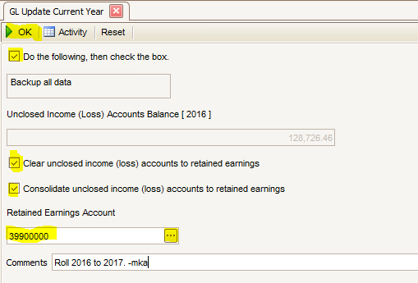

1. When I go to enter Work Order in Ascente, we get a message saying that the fiscal periods are not setup?
   1. This is telling you that the Traverse / System Manager / Company Setup / [Period Conversion](http://www.compusource.com/FTP/Training_Videos/ASCENTE/2017/TraverseSMPeriodConversion_20171001.wmv) record for new payroll year has not been setup. We get a lot of support calls for this.

# Ascente – Service Dispatch

1. What do we need to do in Ascente at year end for Service Dispatch?
   1. Nothing special is required, but we recommend that you complete all your normal monthly processing.
   2. Complete all service billing.

# Ascente – Job Cost

1. What do we need to do in Ascente at year end for Job Cost?
   1. Nothing special is required, but we recommend that you complete all of your normal monthly processing
   2. Complete all job cost billing
   3. Print or file final year end job cost reports that could be needed in the future. This is important because some reports when printed, the billing to date totals can’t be derived in the future by back dating the reports.
   4. See more detail processing notes using this [link](http://servicecontractorsoftware.com/client-support/year-end-procedures-ascente/).

# Ascente – Posting Dates

1. In Ascente, how do I know what fiscal year reports are being posted to?
   1. The G/L Posting Date entered, will determine the fiscal year and period based on the Traverse / System Manager / Company Setup / [Period Conversion](http://www.compusource.com/FTP/Training_Videos/ASCENTE/2017/TraverseSMPeriodConversion_20171001.wmv) record.

# Ascente Mobile Pro

1. The payroll year needs to be advanced to new payroll year after all entries for current/old payroll year are completed and before any for new payroll year are entered.

# Document Retention

1. Can Ascente and Traverse print to PDF files?
   1. Yes, the following video’s detail the process
      1. [Document Retention](http://www.compusource.com/FTP/Training_Videos/ASCENTE/2017/PDF_FileCreationAndDocumentArchivingBasics_2017-10-15.wmv)
      2. [Creating PDF files in Traverse & Ascente](http://www.compusource.com/FTP/Training_Videos/ASCENTE/2017/PDF_FileCreation_2017-10-1.wmv)

# E-mail Template:

Hello,

Please see the information and reference links below and please let me know if these to not address your question or concern:

Here are some links to Ascente & Traverse Year End documents and other support video’s and documents:

* Compusource Website: [www.compusource.com](http://www.compusource.com/) and [servicecontractorsoftware.com](http://servicecontractorsoftware.com/)
* Year End Procedures: [Link](http://servicecontractorsoftware.com/client-support/year-end-procedures-ascente/)
* Training Videos: [Link](http://servicecontractorsoftware.com/client-support/training-videos/)